Relational Model:

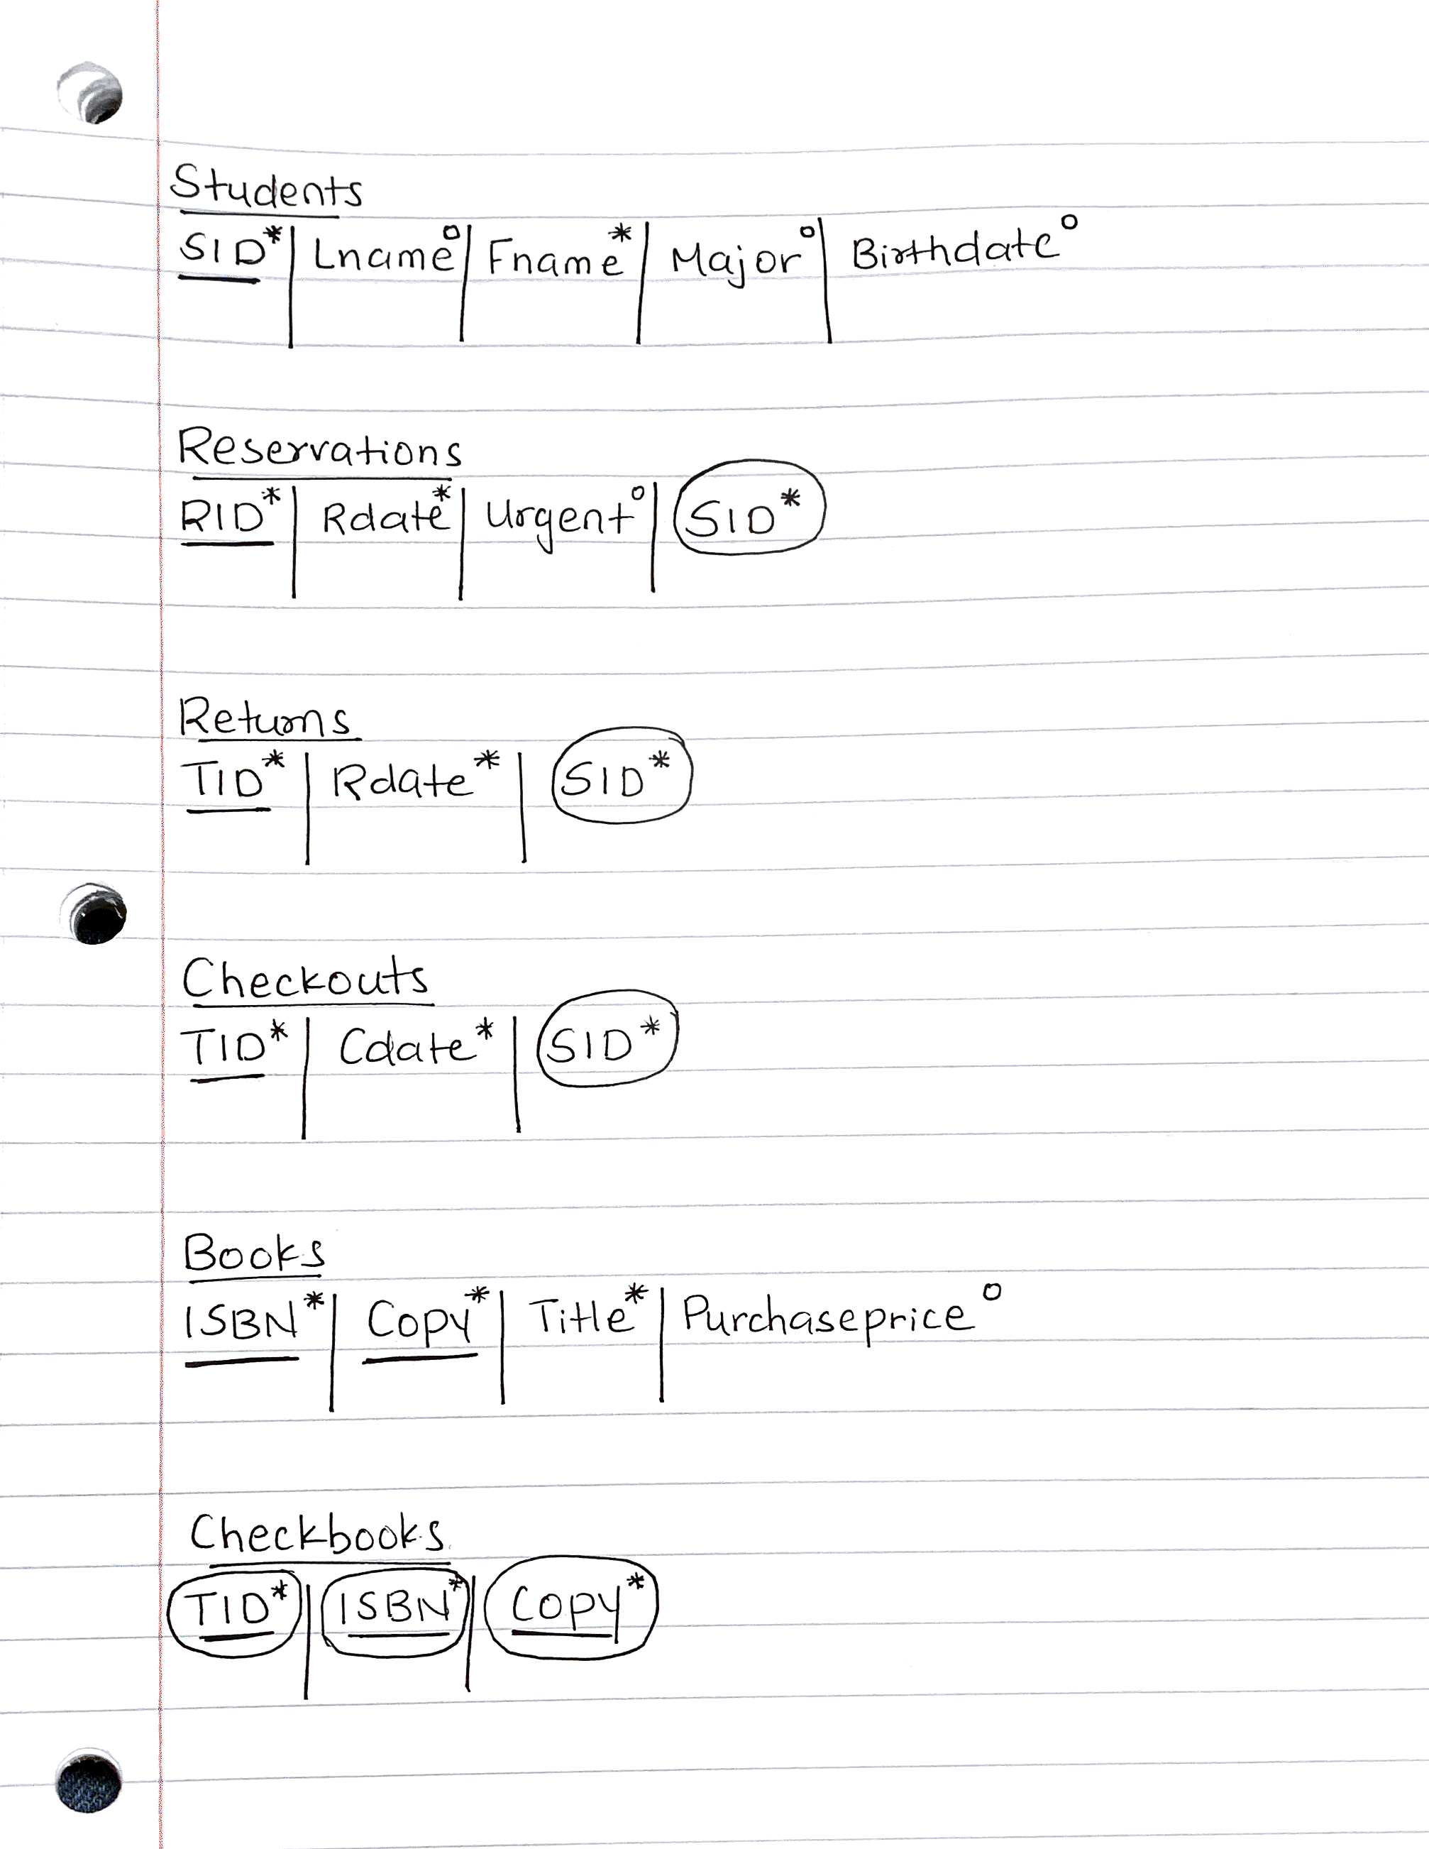

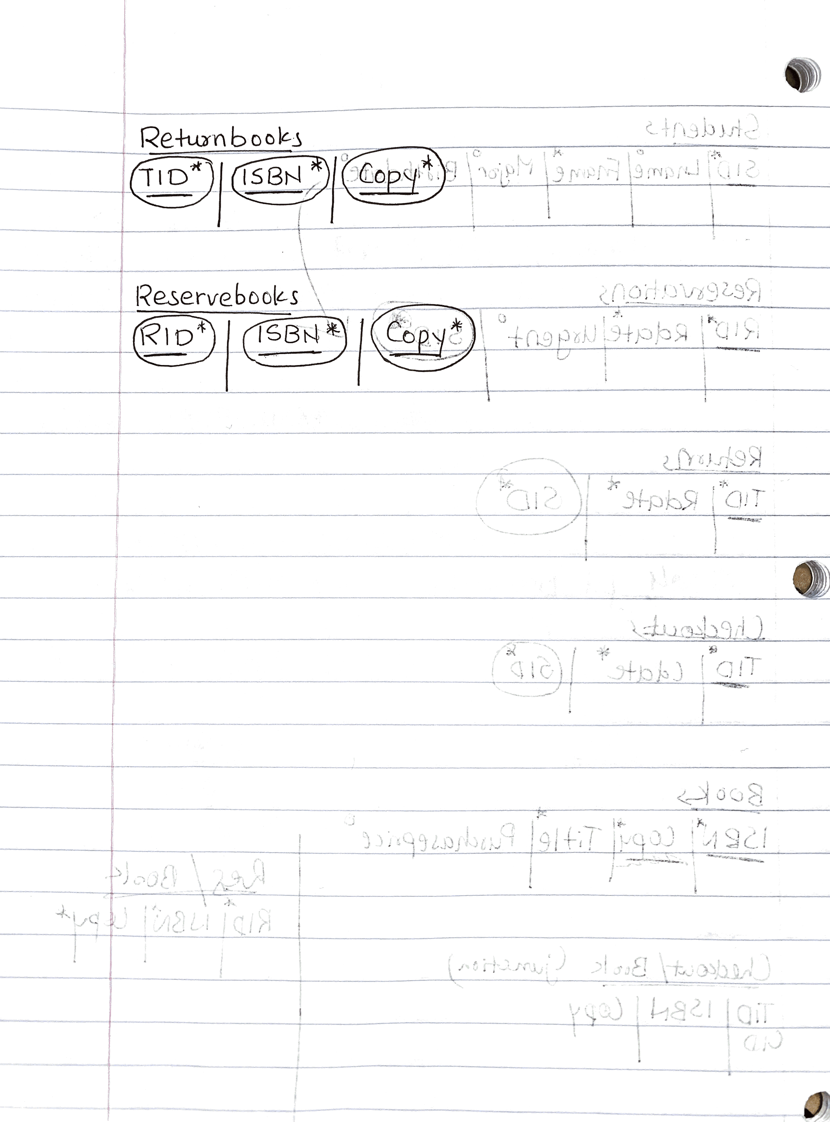

Relational model in Oracle:

create table students (
sid number (7) not null,
Lname char(30),
Fname char(35) not null,
Major char(20),
Birthdate date,
constraint pk_stu primary key(sid)
);

create table reservations (
rid number (7) not null,
rdate date not null,
urgent char(20),
student number (7) not null,
constraint pk_res primary key(rid),
constraint fk_res_stu foreign key (student) references students
);

create table returns (
tid number (7) not null,
rdate date not null,
student number (7) not null,
constraint pk_ret primary key (tid),
constraint fk_ret_stu foreign key (student) references students
);

create table checkouts (
tid number (7) not null,
cdate date not null,
student number (7) not null,
constraint pk_che primary key (tid),
constraint fk_che_stu foreign key (student) references students
);

create table books (
isbn number (13) not null,
copy char(5) not null,
title char (35) not null,
purchaseprice number(3),
constraint pk_book primary key (isbn,copy)
);

create table checkbooks (
tid number (7) not null,
isbn number (13) not null,
copy char (5) not null,
constraint pk_checkbook primary key (tid,isbn,copy),
constraint fk_che_checkbook foreign key (tid) references checkouts,
constraint fk_book_checkbook foreign key (isbn, copy) references books
);

create table returnbooks (
tid number (7) not null,
isbn number (13) not null,
copy char (5) not null,
constraint pk_returnbook primary key (tid,isbn,copy),
constraint fk_ret_returnbook foreign key (tid) references returns,
constraint fk_book_returnbook foreign key (isbn, copy) references books
);

create table reservebooks (
rid number (7) not null,
isbn number (13) not null,
copy char (5) not null,
constraint pk_reservebook primary key (rid,isbn,copy),
constraint fk_res_reservebook foreign key (rid) references reservations,
constraint fk_book_reservebook foreign key (isbn, copy) references books
);

